Title
Main Author¹, Co Author², Presenting Author²
¹Name of Institution1, Address of Institution1
²Name of Institution2, Address of Institution2
Keywords: one, two, three, four
Abstract: The abstract should summarize the contents of the paper in short terms, i.e. 150-250 words.

General
This document contains all relevant information to prepare your extended abstract (or non-peer-reviewed paper) for the CWD 2023. The board of the conference reserves the right to reject the paper if it does not comply with the conditions stated below, even if the abstract has already been accepted.
Please note that papers without peer review will only be available for the conference attendees of DSEC and CWD 2023. The paper will not be published further and will only serve as supplementary information to your presentation.

Structure
The paper must have the following structure. The main section can be designed individually.
- Title
  - Title of your Paper
  - Main Author (for consistency in the form J. Doe and without titles)
  - Co Author (for consistency in the form J. Smith)
  - Presenting Author underlined
- Keywords
- Abstract
- Introduction
- Main section
- Summary / Conclusion
- Bibliography

Formatting
The paper:
- Can be based on your accepted abstract
- Is limited to 8 pages (paper size A4) and 3000 words.
- Font to be used is ‘Arial’ and the font sizes are:
  - 16pt and bold for the title
  - 14pt for the author list
  - 11pt for the abstract and continuous text, institution name and address
  - 10pt for figure captions and references
- The presenting author should be underlined
- Must be written in English
- Must use SI units as well as the usual symbols. Please use a non-breaking space (Ctrl + Shift + Space) between the numerical value and unit (e.g. 1 m/s²)
- Must not exceed 10 MB

Page-, font- and paragraph formatting
The selected formatting in this document must be retained.

Formatting of figures
Images are indicated with the image number and the image title. The necessary formatting is going to be retained if the following table that contains both the image and the caption is copied.
Figure 1: | DSEC and CWD Logo
After inserting the figure the frame of the table must be hidden. This can be done by selecting the frame type “none” under the context menu "borders and shading".
Make sure that the labels and all other text in the figures are in readable font size and not smaller than 10pt.

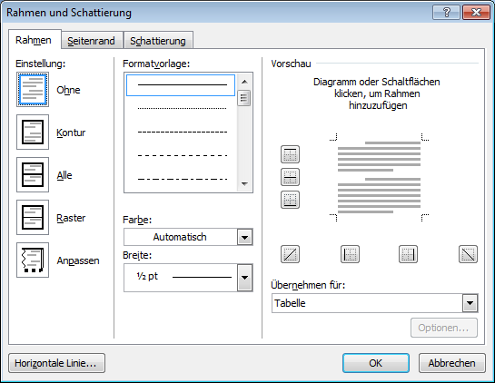
Figure 2: | Hide frame
Images and illustrations (photos, sketches, diagrams and plots) must be clearly visible and have to be adapted to the size of the present format. We ask you to use a minimum resolution of 300 dpi.

Formatting of Equations
Equations are marked with the equation (MS Equation Editor) and the equation number. The necessary formatting is retained if the table below containing both the equation and the equation number is copied. Copying of the table is analogous to the procedure of copying the figure table (see chapter 3.2).
$$E_{pot,tra}=E_{pot,rot}$$ | Eq. 1

Formatting of Tables
Tables are marked with the table number and the table title. The necessary formatting is retained if the table that contains the table, the table number and table title is copied. Copying the table is analogous to the procedure of copying the figure table (see chapter 3.2).
 | column 1 |  | column 2 |  | column 3
line 1 | 1 | 2 | 3 | 4 | 5 | 6
line 2 | 7 | 8 | 9 | 10 | 11 | 12

Table 1: | Example of a table

References

Figure-, equation- or table references
This is a reference to Figure 1.The reference must be added via the "references / labels” function with the corresponding reference type (figure, equation or table). In the drop-down selection menu "reference to" the option "Only category and number" must be selected.

Chapter references
This is a reference to a chapter (see chapter 3.2). The reference must be added via the "references / labels” function with the reference type “heading". In the drop-down selection menu "references to” the "headline number" option must be selected.

Literature references
This is a literature reference [NAM11]. In this case the first three letters of the surname of the author have to be written in capital letters followed by the year of publication enclosed in square brackets (see chapter 5). The references must be managed manually. Please sort the bibliography alphabetically according to the reference abbreviations

Bibliography
[NAM11]  (for books) | Surname of the author, first name of the author: Title.  Circulation  Publishing company, place of publication, year of publication
[NAM11]  (for journals) | Surname of the author, first name of the author: Title.  In: Name of the journal, volume, page references  Publishing company, place of publication, year of publication
[NAM11]  (for editorial works) | Surname of the author, first name of the author: Title.  Circulation  In: Publisher’s name (ed.): Title of the book  Publishing company, place of publication, year of publication
[NAM11]  (for research reports) | Surname of the author, first name of the author: Title (series title and series number).  Publisher, place of publication, year of publication
[NAM11] | Surname of the author, first name of the author: Title.  Address of the website (http://www....)  (date of access to the website)

